**IntelliDealer Parts Accrual**

The parts accrual system is an optional feature in which the system makes entries to the inventory general ledger account when parts are received, thus providing superior inventory account balancing to the parts sub ledger detail.

**Configuration**

Parts accrual general ledger accounts must be created. CDK Global recommends a 1:1 ratio of accrual accounts to parts inventory accounts. Therefore, for each parts inventory account, there should be a corresponding accrual account. These accounts will hold the balance of parts orders that have been received but not vouchered. As such, they must be balance sheet accounts and are typically liabilities.

The parts accrual logic needs the following box checked. **Configuration🡪General Ledger🡪Purchase Orders🡪Location Settings**

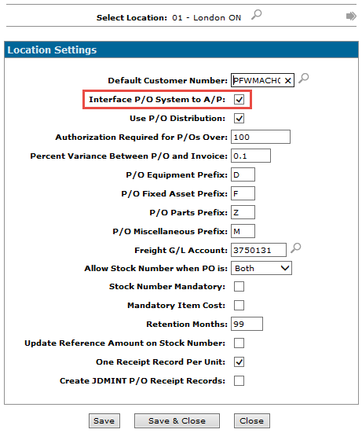

To activate the parts accrual logic on specific parts sales account, a G/L account number needs to be keyed in the "Inventory Accrual" field on that sales account. In the example below, the account 1800001 is assigned as the accrual account for the parts sale account 3660131.

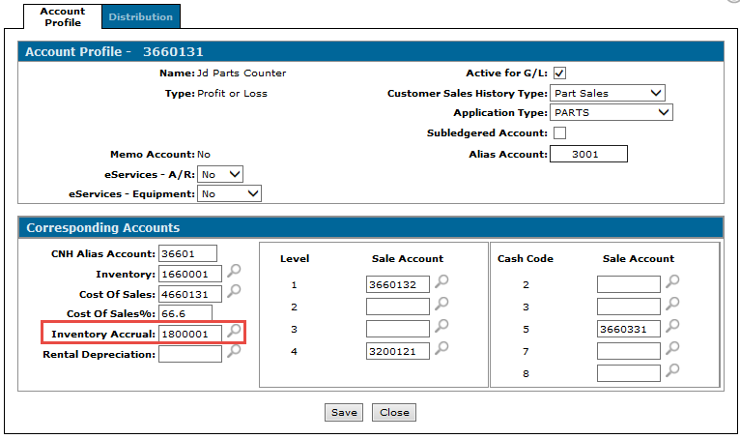

You also need to ensure that the ‘P/O Receipts’ box is checked on the accrual account itself:

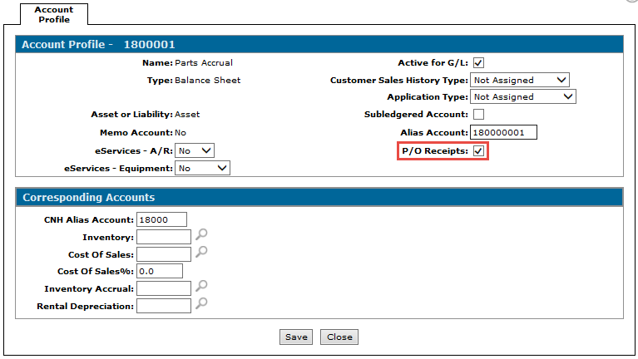

**Receipts a Parts Order as Normal**

Once the above steps have been completed, create, release, receipt and update parts orders as normal.

**Journal Entry Created By Parts Receipt**

1. Here is the journal made when a parts order has been updated and the day end runs (either full or the shortened DAYEND run)

DR Parts Inventory account (e.g. 1660001)

CR Parts accrual account assigned to sales account for the parts received (e.g. 1800001)

Here is an example of one of the accrual journal entries and the resultant detail:

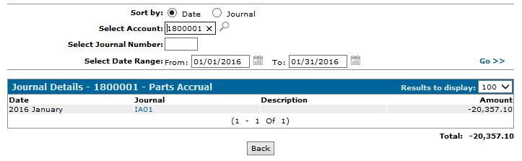

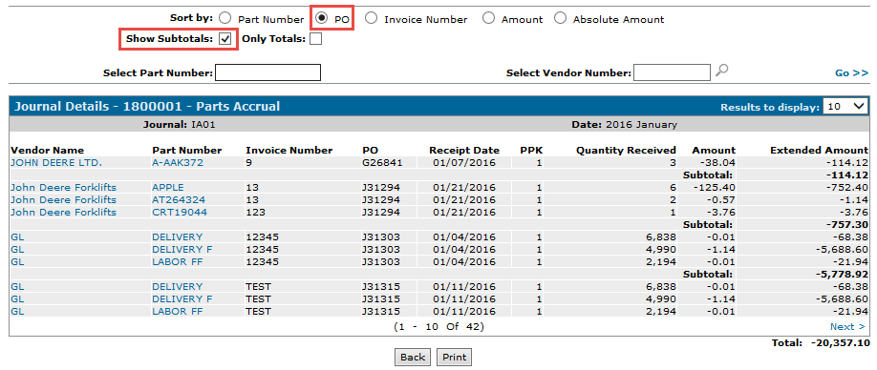

**Creating an A/P Voucher from Accrued Parts Receipts**

a) Select the receipt(s) from the Purchase Order tab when creating an A/P voucher:

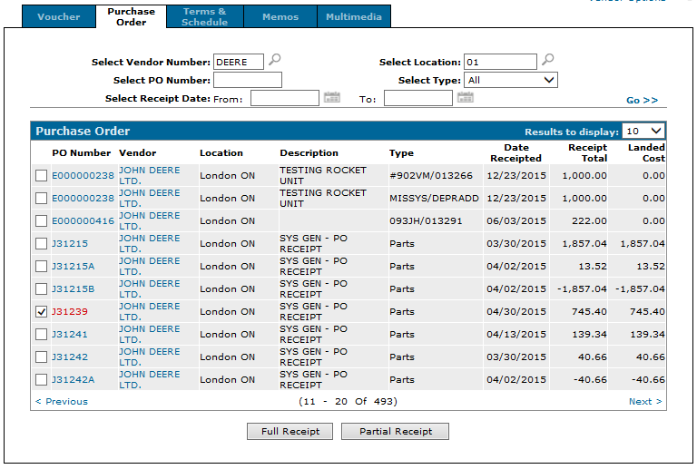

b) The Invoice amount is equal to the total of the receipt(s) selected, and the distribution automatically debits the accrual account:

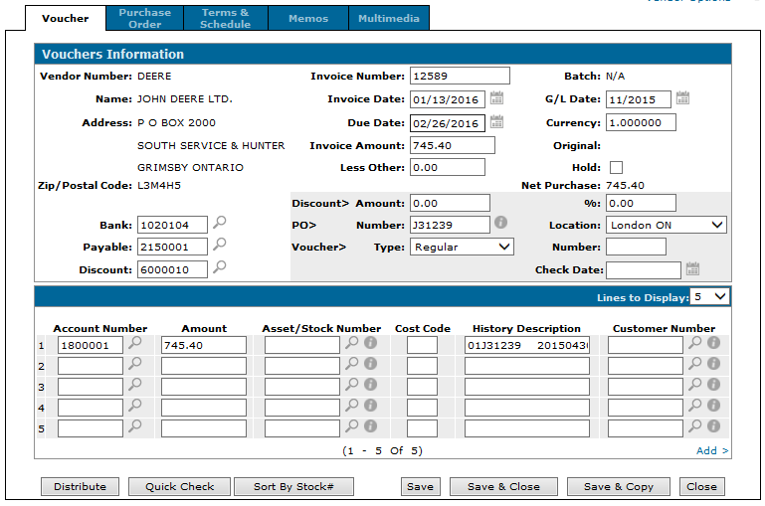

**Deleting Receipt Records**

Hovering over a PO and selecting ‘Change’ in the Purchase Order tab of a voucher will present the Receipt Details. The ‘Delete’ button can be clicked to delete the record. If a record is deleted, and entry to the accrual account may be required.

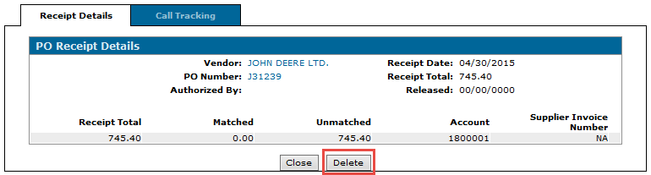

After clicking ‘Delete’ you will be asked to confirm if you want to delete the record.



**NOTE:** CDK Global has a Crystal Report in the Members Only section of our website that is available for download. The report pulls open receipts by branch and by vendor and lists what has been receipted so far. It also has a switch to indicate whether the PO is still open. The report basically replicates the PO selection screen when creating a voucher.

**Files that are populated when the journal entry above is created (technical data)**

**POVENI**

Description Field YTDJRL PURORD Value

Company ZDCO YJCO

Division ZDDIV YJDIV

Branch ZDBR POBR

PO ZDPON POPO

Vendor ZDVEN YJDES or POVEN

**POHDR**

Description Field YTDJRL PURORD Value

Company ZBCO YJCO

Division ZBDIV YJDIV

Branch ZBBR POBR

PO ZBPON POPO

Type ZBTYP 'PAR'

Description ZBDES POCOM

**PORH**

Description Field YTDJRL PURORD Value

Company ZLCO YJCO

Division ZLDIV YJDIV

Branch ZLBR POBR

PO ZLPON POPO

Date Receipt ZLDTE YJDES

Sequence No. ZLSEQ Incremented by for every G/L account per CO/DIV/BR/PO/DATE RECEIPT

System Code ZLSCD '002'

Receipt Tot ZLRTD YJAMT

Reference # ZLREF YJDES

Voucher No. ZLVCH blank

Account No. ZLACC YJACC

Cost Account ZLCC YJCC

**POADD**

Description Field YTDJRL PURORD Value

Company ZVCO YJCO

Division ZVDIV YJDIV

Branch ZVBR POBR

PO ZVPON POPO

Freight Chrg ZVFRC 0

Act/Est Code ZVAEC 'E'

A/P ZVAP 'Y'

**Example of How Files Are Populated**

This is an example of how the PO files are populated for two receipts for PO 1234. The first receipt occurred on Jan 12, 2002 and the other on Jan 15, 2002:

**POVENI** - Note: This record gets created on the first receipt of a parts order. Subsequent receipts for the same order do not get added.

CO DIV BR PO VENDOR

01 01 01 1234 DEERE

**POHDR -** Note: This record gets created on the first receipt of a parts order. Subsequent receipts for the same order do not get added.

CO DIV BR PO TYPE DESCRIPTION

01 01 01 1234 PAR *Order comment*

**PORH -** These entries to be subtotaled and shown as one entry on the on receipt selection screen in Key A/P vouchers (see below) but debited to the appropriate accrual account (ACCT# and CC) on the A/P voucher distribution screen

CO DIV BR PO DATE REC'D SEQ SYS RECEIPT REFERENCE VOUCHER# ACCT # CC

CODE TOTAL

01 01 01 1234 01/12/02 1 002 100 IA10 1234 01/12/02 21401

01 01 01 1234 01/12/02 2 002 75 IA10 1234 01/12/02 21402

01 01 01 1234 01/12/02 3 002 10 IA10 1234 01/12/02 21403

**Receipt Total 185**

01 01 01 1234 01/15/02 1 002 15 IA10 1234 01/15/02 21401

01 01 01 1234 01/15/02 2 002 12 IA10 1234 01/15/02 21402

**Receipt Total 27**

**PO Total 212**

**POADD -** Note: This record gets created on the first receipt of a parts order. Subsequent receipts for the same order do not get added.

CO DIV BR PO FREIGHT CHRG ACT/EST CODE A/P

01 01 01 1234 0 E Y